NRAAO / RIAAO 2019 EDUCATIONAL CONFERENCE
April 28 – May 2, 2019
Gurney’s Resort, Goat Island, Newport, Rhode Island

Name:
Badge Name:
Companion's Name:
Jurisdiction / Firm:
Mailing Address: City/State/Province/Zip:
Phone Number: E-mail:

CONFERENCE REGISTRATION FEES (Circle all that apply) BEFORE 4/1 AFTER 4/1
Full Registration (Sunday – Wednesday)  Includes: Sunday Welcome Reception; Monday Breakfast & Lunch; Continental Breakfast Tuesday & Wednesday; Ice Cream Social Tuesday; Closing Banquet; and all Educational Sessions except for USPAP-extra fee for material. | NRAAO Member Fee: | $275 | $325
 | Non-Member Fee: | $350 | $400
Companion / Retiree Registration (Sunday – Wednesday)  Includes: Sunday Welcome Reception; Monday Breakfast and Lunch; Ice Cream Social Tuesday; Closing Banquet |  | $175 | $225
Daily Registration Fees:
Monday Only (includes breakfast, lunch & sessions) |  | $130
Tuesday Only (includes continental breakfast, ice cream social & sessions) |  | $115
Wednesday Only (includes continental breakfast & sessions) |  | $115
Wednesday: USPAP with full reg (includes course materials) |  | $125
USPAP without full registration (includes course material) |  | $200
Wednesday Banquet Only (includes cocktail hour & banquet) |  | $100
BANQUET MEAL CHOICE: Prime Rib [ ] Salmon [ ]

BECOME A CONFERENCE BOOSTER! YES, I would like to be a BOOSTER. $25
Please list my name in the conference program as a patron.
Name:________________________________________________
Jurisdiction/Firm: _______________________________________
Total Amount Enclosed $_________

***PLEASE IDENTIFY WHICH EDUATION SESSIONS YOU WILL BE ATTENDING***
MONDAY AFTERNOON | TUESDAY MORNING | TUESDAY AFTERNOON
[ ] Real Estate Title | [ ] Green Commercial Buildings | [ ] Mass Appraisal Benchmarks
[ ] Leadership, Education & Assessment Profession | [ ] Unique & Challenging Homes | [ ] Stress Management / Yin Yoga
[ ] Preparing Valuation Appeal
WEDNESDAY MORNING | WEDNESDAY AFTERNOON | WEDNESDAY ALL DAY
[ ] Advanced Data Collection | [ ] Hands-On GIS – Laptop required | [ ] USPAP (extra fees apply – see above)
[ ] Contamination & Valuation Issues | [ ] Teaching Adult Students

Make Checks/Voucher Payable to: NRAAO/RIAAO 2019 MAIL TO:
Hotel Registration: West Greenwich Town Hall
Gurney’s Resort: 1-401-851-3366 Attn: Charlene Randall
Conference Code: NRAA 280 Victory Highway, West Greenwich RI 02817

NRAAO / RIAAO 2019
SOCIAL REGISTRATIONS

MONDAY, APRIL 29TH, 7-10PM, ROSE ISLAND BALLROOM $100 per person $_________
PRESIDENT’S BASH!

Dinner with a New England flare! Dancing to the music of DJ “Tommy Tunes”. Come mix and mingle and celebrate NRAAO Past Presidents. Price includes appetizers, dinner, dessert, entertainment, two drink tickets. Cash bar following.

TUESDAY, APRIL 30TH, ANNUAL GOLF TOURNAMENT $125 per person $__________
GREEN VALLEY GOLF COURSE
371 Union Street, Portsmouth, RI 02871
www.gvccri.com

8:30 AM CONTINENTAL BREAKFAST
9:00 AM SHOTGUN START
1:00 PM LUNCH & PRIZES

The Green Valley Country Club is an 18-hole championship course, located in picturesque Portsmouth, Rhode Island. Known as Newport’s finest semi-private country club, it is open to the public.

FOURSOME:

Player #1 ______________________________ Player #2 ______________________________

Player #3 ______________________________ Player #4 ______________________________
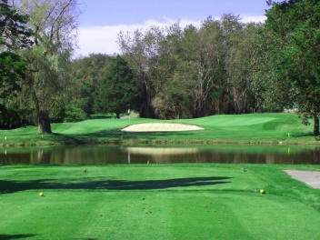
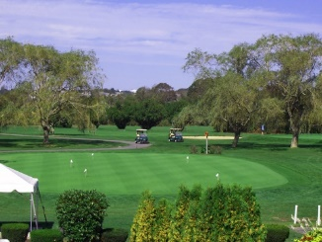

WEDNESDAY, MAY 1ST, CLOSING BANQUET $100 per person $__________

Full registrations include the formal banquet on Wednesday evening. If you’re not a full registrant, don’t miss out on the hottest band in New England! “Roger Cereci’s All Starz” are an 8-piece band, and will have you dancing all evening long. Extra banquet tickets are $100 and include the cocktail hour prior to dinner, dancing and Installation of NRAAO Officers. Black tie optional, formal attire.

http://rogerceresi.com/allstarz.html

Total Enclosed $__________

